**Experiment -2**

Aim: Understanding vagrant file - Configuration - CPU, RAM, Storage, Provisioning (Shell Script).

1) Run vagrant init

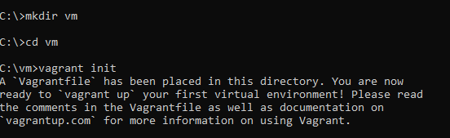

2) Changing the vagrantfile created in the directory

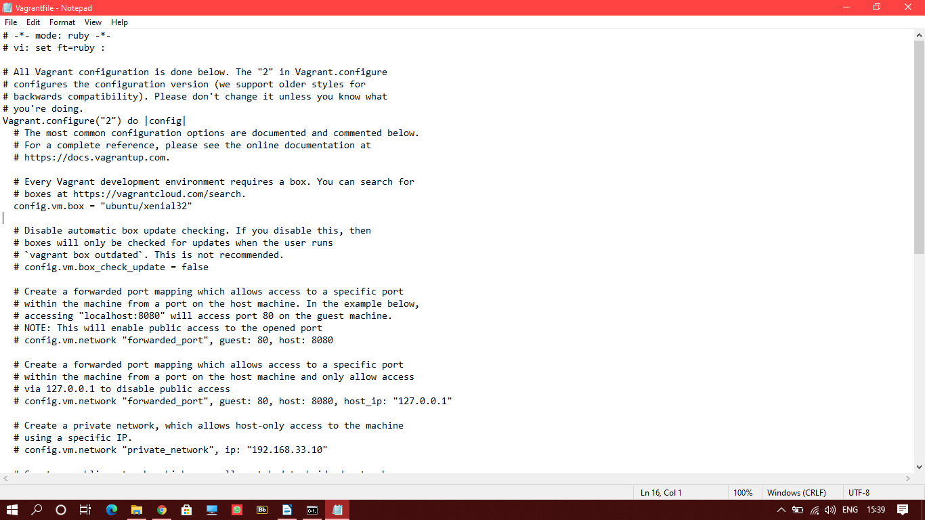

3) Run the ‘vagrant up’ command to create the virtual machine

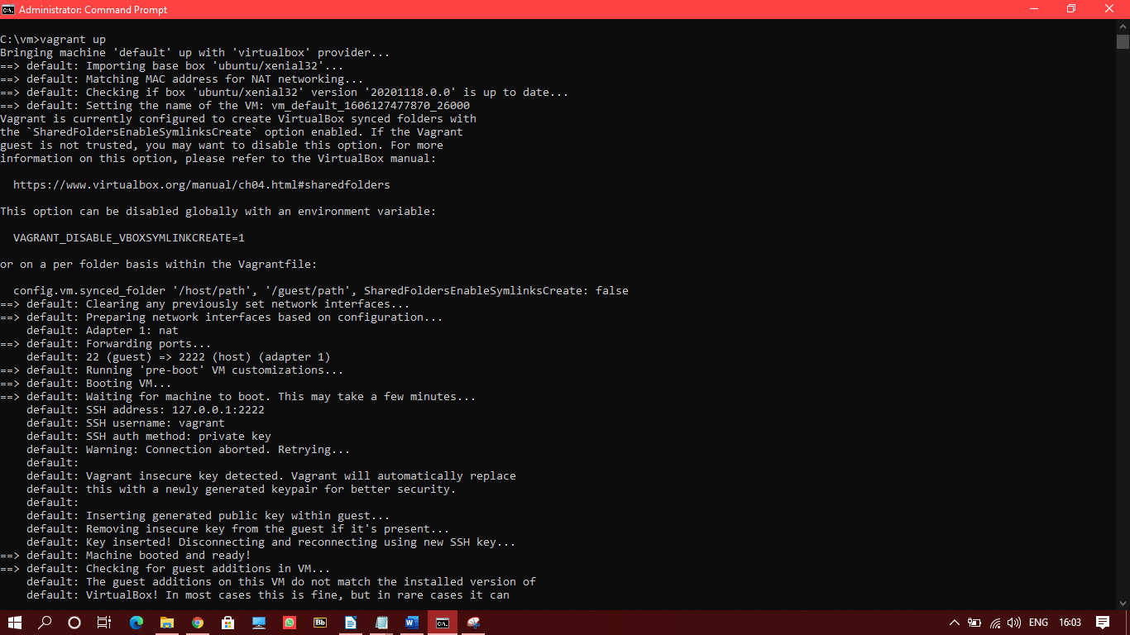

4) Run the ‘vagrant ssh’ command to a attach the ubuntu image created to the windows command line

